Minutes of April 27, 2022, 2-3:30pm
Present: Margaret Watt (Positive Directions & parent), Katie Gallo (media rep & parent), Anamilena Moreno (Norwalk ACTS), Jennifer Rolinson (NPS), Paige Sinchak (MFCGC), Nina Chanana (evaluator), Marilyn Moreau (FCA), Denique Weidema-Lewis (Norwalk ACTS), Daniella Arias (The Hub), David Walenczyk (Youth Services), Vanessa Wilson (Positive Directions), Kelly Meier (Health Dept), Diana Revolus (advocate, business owner, council member, parent), Aubrey Grodin (FCA), Diamond Sead (HSC and parent), Doreen Anderson (parent & community advocate), Edson Rivas (TCC), Maggie Young (Liberation Programs), Dajuan Wiggins (YBI and parent), Jahliah Green, Kelsey Ciarleglio (High Focus Centers), Eve St. Surin (CAAWC), Jodi Giorlando (CT Counseling Centers), Lisa Gregory (Norwalk Hospital), Lt Lepore (NPD), AnaVivian Estrella (City)

- Welcome & agenda for today’s meeting
Welcome to new participants
    - Lisa Gregory, peer engagement specialist on Community Care Team at Norwalk Hospital
    - Lt Marc Lepore, NPD, commander special services division (narcotics, vice, organized crime) - do compliance checks with bars & restaurants and vape shops
    - AnaVivian Estrella, new Human Services Director at the City of Norwalk

- Review agenda ; Announcements / updates
  - Jennifer Rollinson, NPS nursing supervisor: just got Narcan wall units next to AEDs in all NPS schools
  - Legislative session is wrapping up
  - Pride in the Park is on June 11, 2022, 12-9PM, Mathews Park. For those who want to have a booth at the event, please complete the form. For more information, please go to www.ctpridecenter.org.
  - On May 14, 6-10PM at the Norwalk Inn, the Youth Business Initiative will be hosting a Youth Gala to benefit Norwalk seniors. It is in the hopes of raising $10,000; 100% of what is raised will go directly to graduating youth. Please consider contributing (even if you’re unable to go), sharing the event within your networks, or purchasing a ticket for the event (A Night of Inspiration Scholarship Gala Tickets, Sat, May 14, 2022 at 6:00 PM | Eventbrite). For a highlight of 2021-22 YBI highlights, watch here: YBI Students Video - YouTube All are advised to follow YBI on social media at ybi_ct.
  - Positive Directions is looking for new Board members! For more info, reach out to Vanessa Wilson at vwilson@positivedirections.org

- Highlights of Recent Coalition Activities
  - Provided Narcan training at NCC (Diamond trained 60 nursing students were trained and were able to leave with a NARCAN kit) and at CT Counseling Centers methadone clinic (Margaret hosted training for 10-12 people…) There will be a NARCAN training being offered at Norwalk City Hall during National Prevention Week on May 9th. More information later in the agenda.
  - Provided Question, Persuade, Refer (QPR) suicide prevention
training to teens at BMHS. Youth survey data continue to highlight the mental health needs of youth and the greater community. Another group of CGS students will be trained. Positive Directions and TheHub both offer virtual QPR trainings monthly (info at positivedirections.org/events). Spanish QPR training is also available. Everyone should know how to intervene; if you’d like to bring the training to a Norwalk organization, please let Margaret know.
  - Guest-taught on marijuana at NHS health classes. Due to the professional development offered, health teachers are integrating marijuana into Health 1.
  - Our teen group, Norwalk Strong, ran marijuana awareness tables last month and doing alcohol awareness tables this week in both high schools
  - We had a mental health coping skills table at BMHS.
  - Alcohol committee did not meet this month. We have been using alcohol awareness and Talk.They Hear You campaigns on social media. Parent newsletter went out mid April with alcohol awareness month info and going out through the schools tomorrow with additional info for May.
    - ACTION: Coalition members are asked to always share / post the newsletter with their colleagues, neighbors, clients, social media networks. If you aren’t getting the newsletter, be sure to subscribe to thenorwalkpartnership.org.
  - Marijuana committee met, including Ordinance Committee member. Ginger & Margaret met with someone who wants to open MJ retail store in Norwalk.
  - Lots of planning for May (Mental Health month & National Prevention Week!

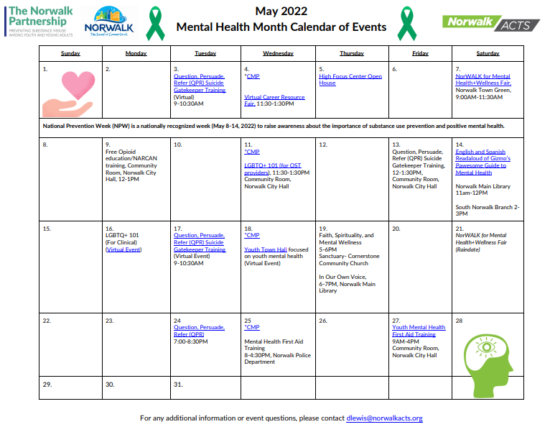
- Mental Health Month Update

NorWALK for Mental Health + Check-In Wellness Fair on May 7th (rain date May 21st) is the kickoff for the calendar of other mental health trainings and events.

Planned elements of the event: press conference, 20 or so provider booths, laughter yoga, speakers, awareness walk, Griffin Health will have youth and adult vaccines & boosters .
    - Planning to bring a group to walk: YBI, Norwalk Mentoring, FCA,
    - Collective impact: thanks to TNP, Norwalk ACTS, NCC, CCFC for financially supporting elements of this. Kids in Crisis and Stop & Shop are donating water bottles.
    - Dajuan has reached out and confirmed that EverybodyEatz food truck, and will be on planning committee next year!
    - Griffin Health will be there for 5-12 yo and adult vaccines until 12pm.

Free trainings - the calendar is in the April-May parent newsletter and enclosed here. This is still a working calendar with additional opportunities that are in process.
    - Opioids/Narcan training May 9th at noon at City Hall
    - Community Mindfulness Project offering mindful Wednesdays
    - LGBTQ+ 101 - 2 opportunities, one for adults who work with youth (live at City Hall) and one for school-based providers
    - QPR suicide prevention training live at City Hall on Friday May 13th at noon, also multiple online options (max of 30 for each training)
    - In Our Own Voice presentation at the library
    - Read-aloud for young children of Gizmo’s Pawsome Guide to Mental Health in English and Spanish at the libraries
    - Faith training
    - Mental Health First Aid and Youth Mental Health First Aid (max of 30 for each)

- Update from NPD
  - Compliance and other data-Seeing an increase in youth using vape products. Lots of complaints from schools and parents. Have been doing compliance checks. A year ago not many stores were in compliance when they went out for the first time. Second time, more of them were. Educating retailers about the age. Parents, school administrators, and school security guards are concerned.
  - Question about where are kids getting vapes: Some online, some from friends. Besides fines, NPD is looking at other strategies to curb youth’ access to vapes. Health dept license is one option. This could be an opportunity to work together (TNP, NPD, Health Department, Ordinance/Safety Committee) on the strategy together. For those who are interested, please go to the upcoming Marijuana Committee.
  - Several liquor compliance checks in recent months. NPS is working with trained underage kids to implement compliance checks.
  - Question: Do you have a way to track online?
  - Question: What would you guess is the % of vapes THC vs nicotine? They are being used for marijuana products….it is happening and concerning. Clearly vaping is coming back now that the school system is in-person.
  - Discussion about how police interact with kids, including breaking up a gathering, so they feel safe vs intimidated and would have a relationship where they would be willing to reach out to police when needed. NPD encourages people to reach out with any concerns.
  - For any additional questions, please email mlepore@norwalkct.org or call 203-854-3040
  - Discussion around prom & graduation- Based on last month's how to make sure we’re working on safe and sober celebrations? The administration doesn’t organize the post prom planning. If anyone has a up to date on either prom or graduation plans at the high schools. Will follow back on. For those who have high school children, TNP members should connect.

- Marijuana Messaging
  - Watched 5 short videos (PSAs and ads) developed by other CT coalitions to get feedback. Plan to use whatever feels appropriate in Norwalk and develop our own messaging that meets other needs. (Watch them at https://www.tpaud.org/let-s-mentionprevention-marijuana )
  - ACTION: Please contact Lamar https://www.lamar.com/About/Support/ContactUs and state Attny General’s office about the billboard on Westport Ave

- Upcoming Meetings - RSVP to Rebecca at roliveira@positivedirections.org for Zoom
  - TNP marijuana/vaping committee Thurs. May 5th, 4-5pm
  - TNP alcohol committee Wed. May 11th 4-5pm
  - NEXT COALITION MEETING: May 25, 2022 from 2-3:30pm LIVE!!!
  - No meeting in June or August. Working meeting in July to prepare for next year.

